Experiment Report of Digital System

Adder Design

**- Name: Han Yichen 韩一尘**

**- Student ID: 22722051**

**- Date: 2023/10/04**

## Aim

1. Understand the basic principles of an adder

2. Assemble a half adder and a full adder by analyzing the logic of the adder

3. Assemble a 4-bit adder using the 74LS283 chip

## Content and steps

1. Analyze the logic and principles of an adder

2. Write its logical expression and draw a circuit diagram

3. Connect the circuit to make a half adder and a full adder

4. Assemble a four bit adder using the 74LS238 chip

## Circuit

Half Adder:

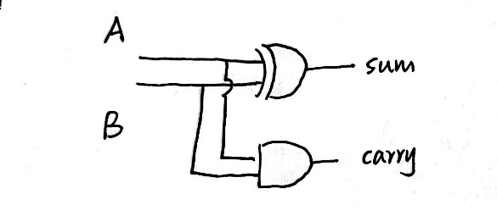

Full Adder:

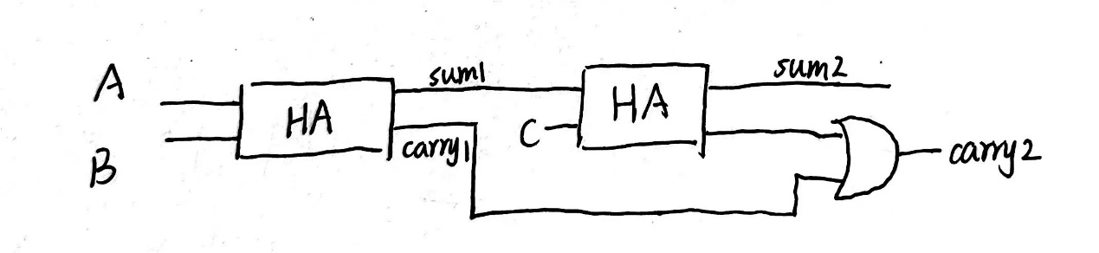

## Analysis

Adding two numbers produces two parts of the number, one is the base number and the other is the carry number. Through the analysis of binary addition, we can obtain the truth table shown in the figure. It is not difficult to find that the NOR operation is performed on sum, and the AND operation is performed on carry. Based on this, we can design a semi adder.

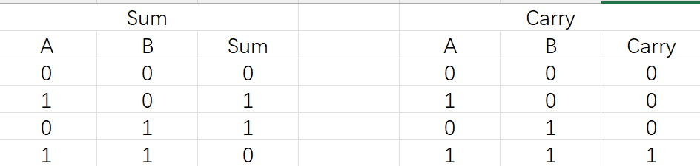

For operations with two or more digits, multiple half adders need to be connected in series. Due to the fact that a single bit input of Carry can be considered as 0, there is no need to add an additional input signal for each bit, while for higher order numbers, an OR operation is required for Carry. Based on this, we can design a full adder.

The 74LS283 chip can be seen as a set of four bit adders composed of four sets of full adders as shown in the figure.

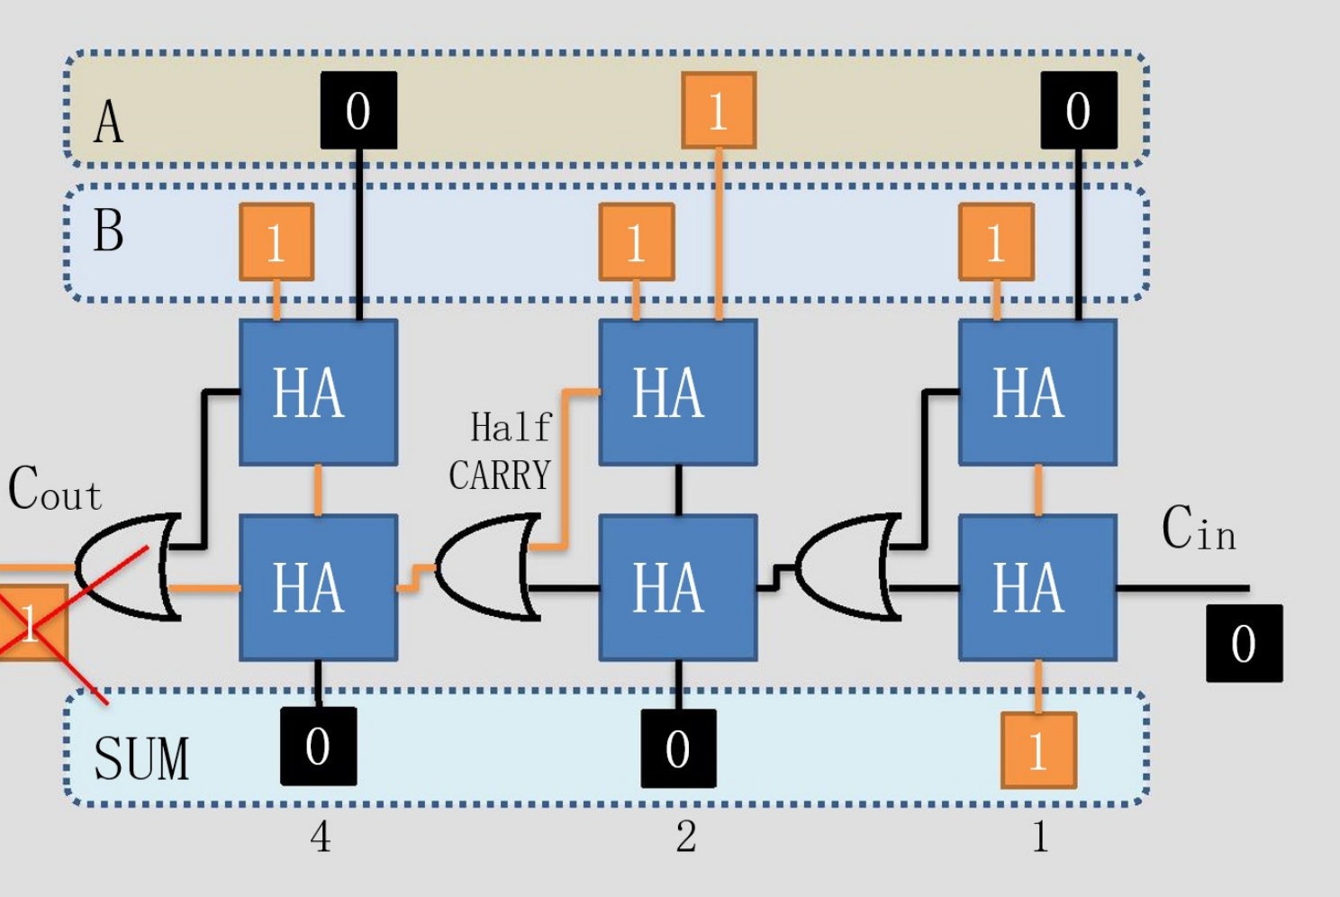

## Result

The connection method for this experiment is shown in the figure.

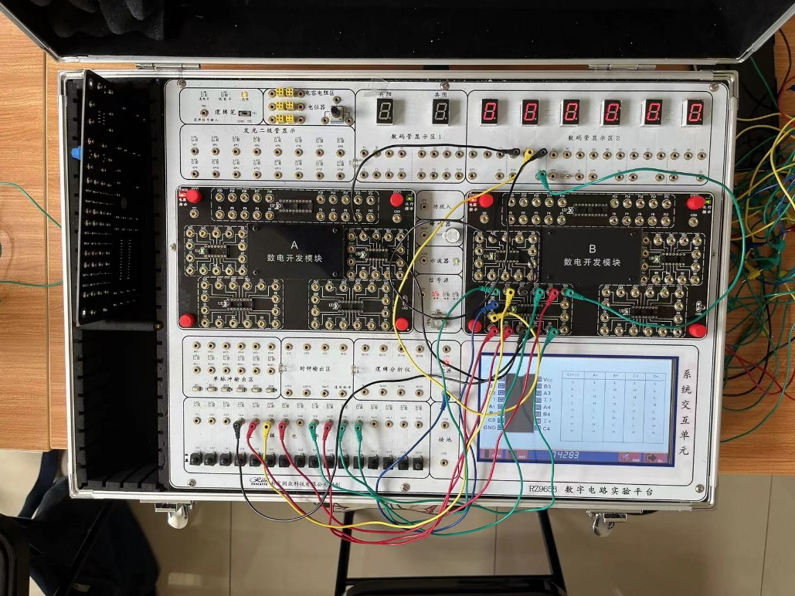

By connecting the half adder and the full adder, and comparing them with the truth table, it was found that the connection was correct if the same results were obtained. For the experiment of the 74LS283 chip, the four pins at its output end were connected to the input holes of 1, 2, 4, and 8 (i.e., 0001，0010，0100，1000 decimal conversion) in the digital tube display area. By testing the output values under different conditions and comparing them with the actual calculation results, it was found that the output results were correct, and the functionality of 74LS283 was successfully verified.